**Integrating Sendgrid Service**

1. Create API

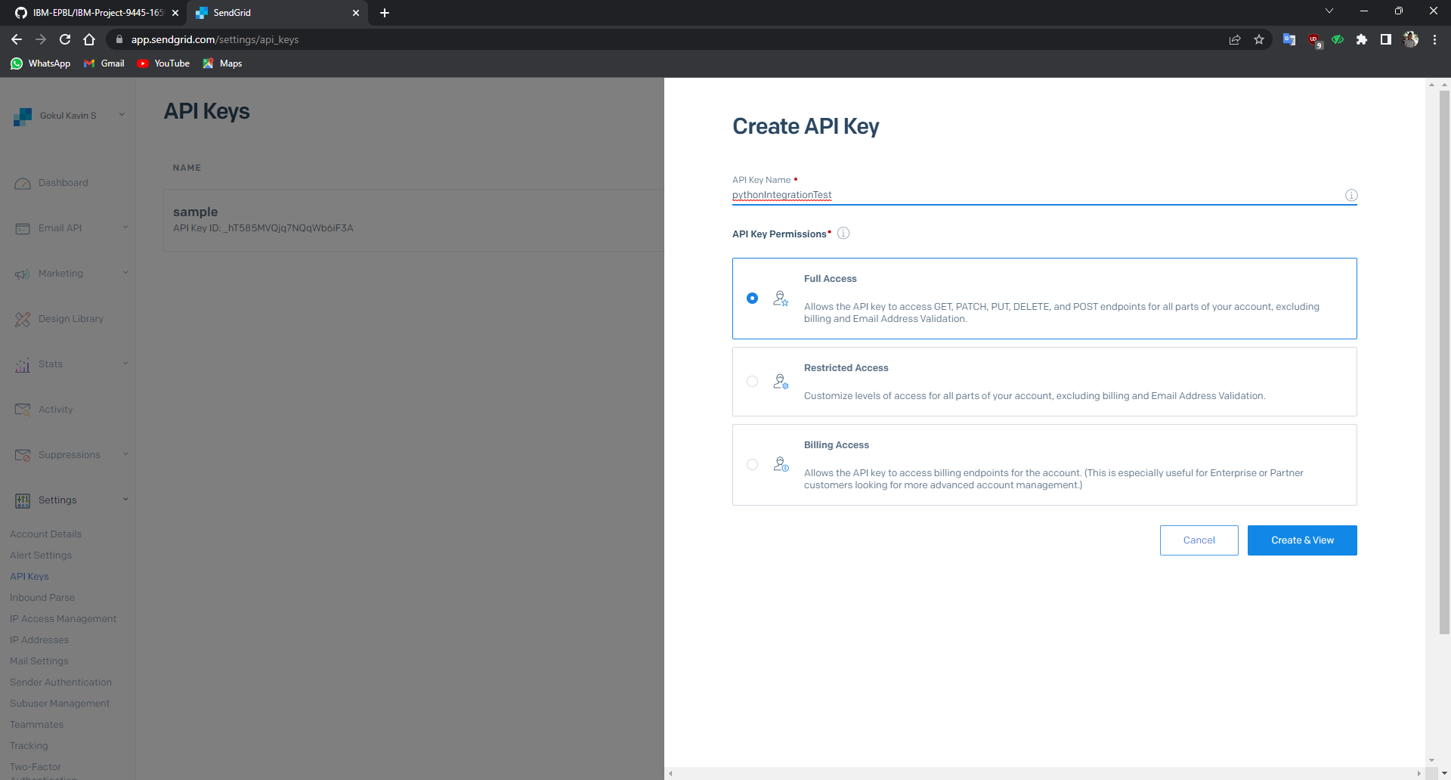

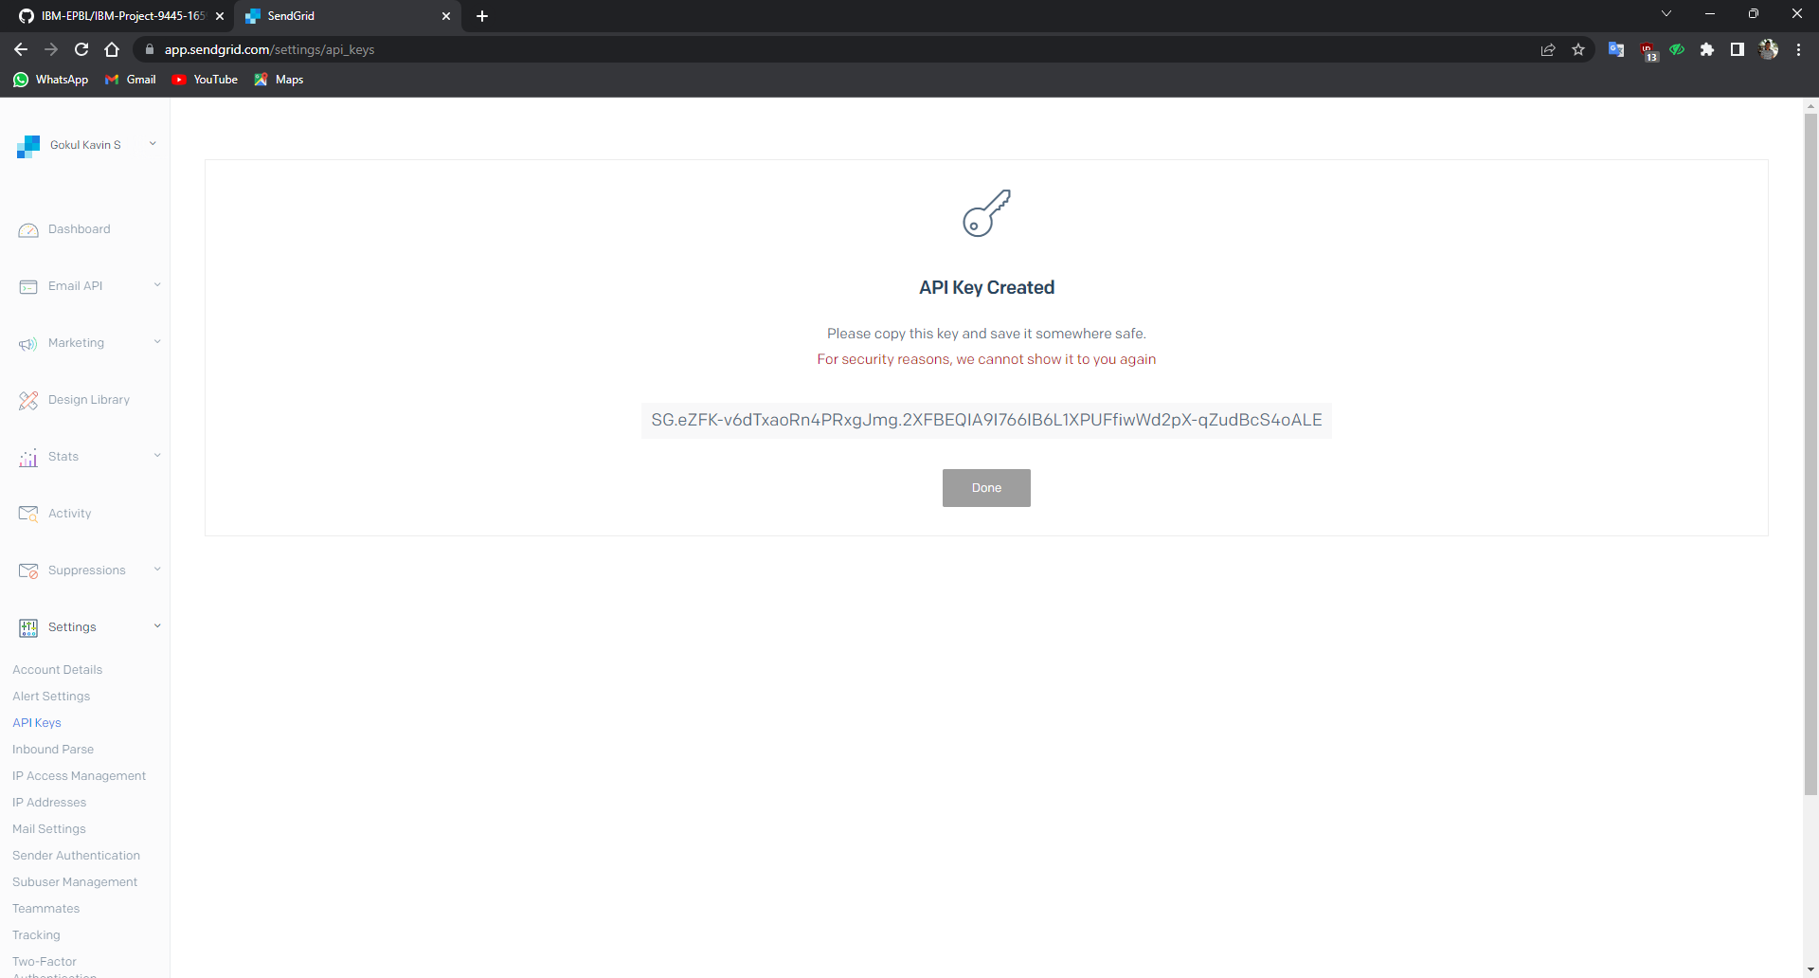

Private Access key

1. Integrating with python

import os

from sendgrid import SendGridAPIClient

from sendgrid.helpers.mail import Mail

message = Mail(

from_email='from_email@example.com',

to_emails='to@example.com',

subject='Sending with Twilio SendGrid is Fun',

html_content='<strong>and easy to do anywhere, even with Python</strong>')

try:

sg = SendGridAPIClient(os.environ.get('SENDGRID_API_KEY'))

response = sg.send(message)

print(response.status_code)

print(response.body)

print(response.headers)

except Exception as e:

print(e.message)

1. Output